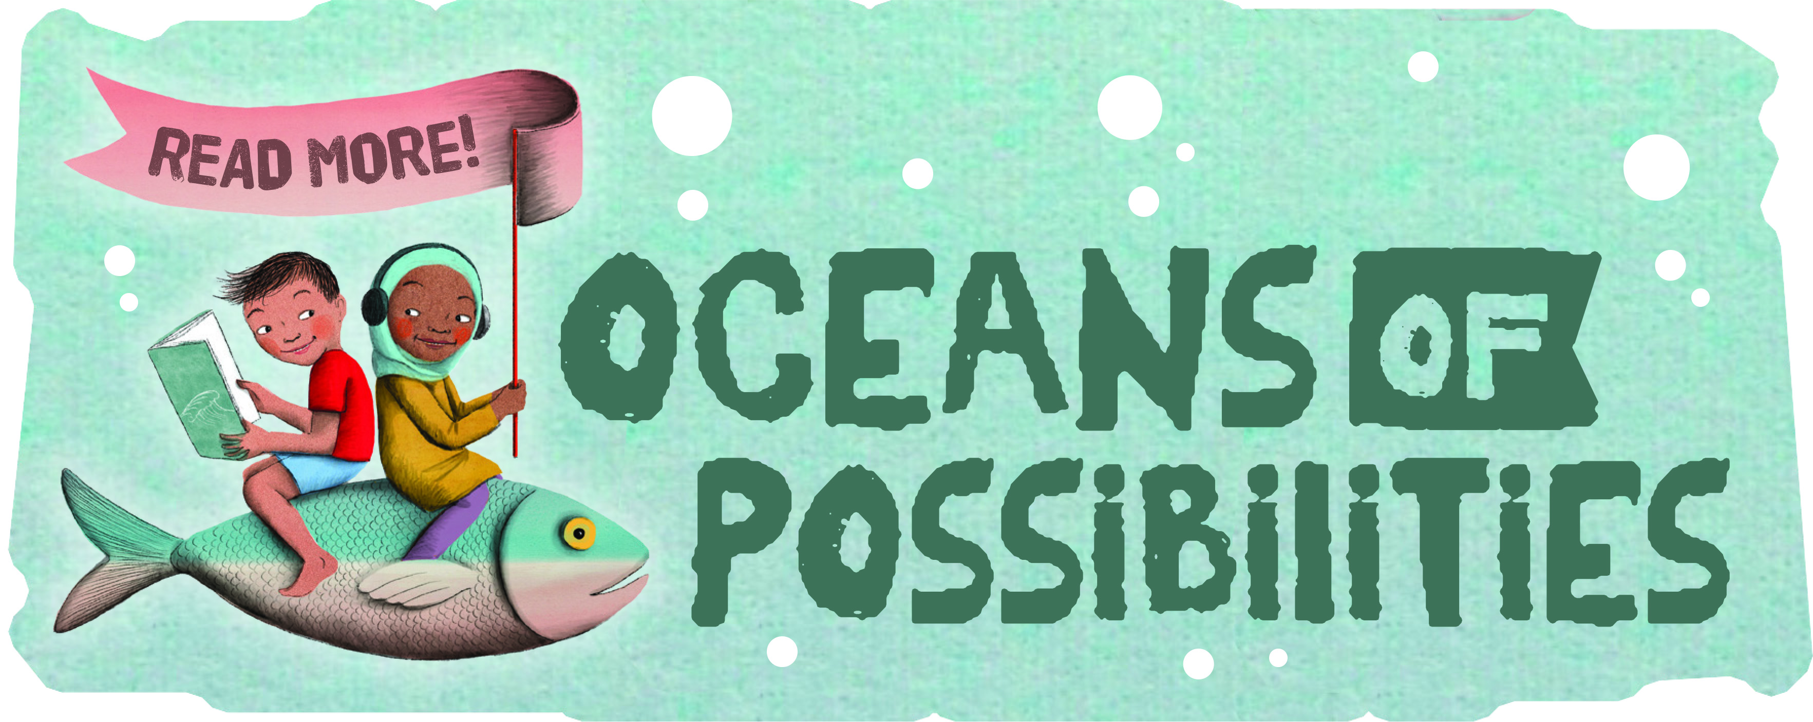

SUMMER READING AT THE SPENCER LIBRARY
June 30 @10:30 AM
Tanglewood Animals

July 7 @10:30 AM
Spoonman

July 11 @ 10:30 AM
“Hansel and Gretel”
Woodwind Quintet

July 14 @10:30 AM
Dirtmeister

July 21 @ 10:30 AM
Robert Rogers Puppets

July 25 @ 10:30 AM
“In the Hall of the Mountain King”
String Trio

July 28 @ 10:30 AM
Rick Rogers –storyteller

August 4 @ 10:30 AM
Games Truck
Pizza Celebration Party

Time sheets for keeping track of reading are available at Summer Reading programs or anytime the library is open.

Prizes awarded for completed and returned time sheets.

All programs are at the Spencer Municipal Building.

