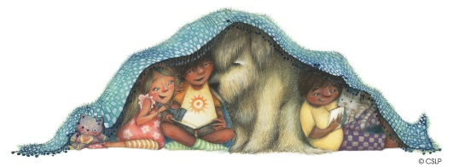

**Adventure Begins at Your Library!**

**SPENCER LIBRARY**

**SUMMER READING**

**JUNE 27- 10:30 AM TANGLEWOOD ANIMALS**

**JULY 11- 10:30 AM**

**GOBOTS**

**JULY 18- 10:30 AM**

**SIR JAMES BALLOONIST**

**JULY 25- 10:30 AM**

**REPO ANIMALS**

**AUGUST 1 – 10:30 AM**

**DINOSAUR ADVENTURE SHOW**

**AUGUST 8- 10:30 AM**

**TALE WISE.**